INDEX

Name of Work: Making emergency exit on first floor with spiral fire escape and making concrete path for block B in pre-engineered building near Flight lab.

Sl. No. | Description | Page
1 | Index Page | 1
2 | Notice inviting E-tenders | 2
3 | PART-A | 3
4 | Information and e-Tendering for Contractors | 4-7
5 | Notice Inviting Tenders (Form CPWD–6) | 8-12
6 | Tender (Form CPWD–7) | 13-18
7 | Salient/Mandatory requirement for tender | 19
8 | PART-B | 20
9 | Quality Assurance of the work | 21-22
10 | Additional terms and conditions & (Special condition for Paints) | 24-26
11 | Special Condition for Material | 27
12 | Additional conditions for Civil Works | 28-31
13 | General Specifications for Civil Works | 33-33
14 | Indemnity Bond | 34-40
15 | Performance Security Guarantee bond | 41-43
16 | Form of Earnest money (Bank Guarantee) | 44-45

NIT amounting to Rs. 5,90,691/- (Rupees Five Lac Ninety Thousand Six Hundred Ninety One Only) is approved.

[Certified that this N.I.T. contains 45 (Forty Five) pages + BOQ contains 02 pages Total 47 pages only].

Sr. Assistant Engineer (S.G.) |  | Superintending Engineer
I.W.D. Division-II |  | I.W.D.
I.I.T., Kanpur |  | I.I.T., Kanpur

INDIAN INSTITUTE OF TECHNOLOGY KANPUR
INSTITUTE WORKS DEPARTMENT
DIVISION-II

Notice Inviting e-Tenders No. 20/Civil/D2/2020-21

The Superintending Engineer, IWD, IIT Kanpur invites on behalf of Board of Governors of IIT Kanpur online percentage rate tender on single bid system from the Registered contractors in CPWD, BSNL, UPPWD,MES & Central PSUs in appropriate category for the following work:

- NIT No. 20/Civil/D2/2020-21/03, Name of work: Making emergency exit on first floor with spiral fire escape and making concrete path for block B in pre-engineered building near Flight lab, Estimated cost Rs. 5,90,691/-, Earnest money Rs. 11,814/-, Period of completion 02 Months, Last time & dated of submission of bid 3.30 PM on 08.03.2021.

The bid forms and other details are available on website www.iitk.ac.in/iwd/tenderhall.htm,www.eprocure.gov.in/cppp/latestactivetenders. But the bids can only be submitted online on www.tenderwizard.com/IIT.

No. IWD/Div-II/2021/109 Dated:23.02.2021 Superintending Engineer

INFORMATION AND INSTRUCTIONS FOR CONTRACTORS FOR e-TENDERING FORMING PART OF NIT AND TO BE POSTED ON WEBSITE
The Superintending Engineer, IWD, I.I.T., Kanpur on behalf of Board of Governors of IIT Kanpur invites online percentage rate tender from approved and eligible* contractors for the following work(s):
S. No. | NIT No.20/Civil/D2/2020-21/03 | Name of work and location | Estimated cost put to tender (in Rs.) | Earnest Money | Period of Completion | Last date & time of submission of tender | Period during  which EMD,  e-Tender  Processing  Fee and other  Documents  shall be  submitted | Time &  date of  opening  of tender
1 | NIT No.20/Civil/D2/2020-21/03 | Making emergency exit on first floor with spiral fire escape and making concrete path for block B in pre-engineered building near Flight lab. | 590691/- | 11814/- | 02 Months | Up to 3:30 PM on 08.03.2021 | After last date and time of submission of tender and up to 3:30 PM on 09.03.2021 | At 3:30 PM on 10.03.2021

*The eligible contractors means registered in CPWD, BSNL, MES, UPPWD, Central PSUs & working contractors of IIT Kanpur if they furnish the definite proof from the appropriate authority of having satisfactorily completed three similar works of value 40% or two similar works of value 60% or one similar work of value 80% of estimated cost during last seven years.

The enlistment / registration of the contractors should be valid on the last date of submission of tenders.
In case the last date of submission of tender is extended, the enlistment / registered of contractor should be valid on the original date of submission of tenders.
- The intending tenderer must read the terms and conditions of CPWD-6 for e-Tendering carefully. He should only submit his tender if he considers himself eligible and he is in possession of all the documents required.
- Information and Instructions for tenderer posted on website shall form part of tender document.
- The tender document consisting of plans, specifications, the schedule of quantities of various types of items to be executed and the set of terms and conditions of the contract to be complied with and other necessary documents can be seen and downloaded from website www.iitk.ac.in/iwd/tenderhall.htm,www.eprocure.gov.in/cppp/latestactivetenders free of cost and shall be submitted on line on website www.tenderwizard.com/IIT.
- The tender can only be submitted after uploading the mandatory scanned documents as per list given below.
- The intending tenderer has to fill all the details such as Banker's name, Demand Draft/Fixed Deposit Receipt /Pay Order/ Banker's Cheque/Bank Guarantee number, amount and date.
The amount of EMD can be paid by multiple Demand Draft / Pay Order / Banker's Cheque / Deposit at call receipt / Fixed Deposit Receipts along with multiple Bank Guarantee of any Scheduled Bank if EMD is also acceptable in the form of Bank Guarantee.
- Those contractors not registered on the website mentioned above, are required to get registered beforehand. If needed they can be imparted training on online bidding process as per details available on the website.
- The intending tenderer must have valid class-III digital signature to submit the tender.
- On opening date, the contractor can login and see the tender opening process. After opening of tenders he will receive the competitor tender sheets.
- Contractor can upload documents in the form of JPG format and PDF format.
- Contractor must ensure to quote rate of each item. The column meant for quoting rate in figures appears in pink colour and the moment rate is entered, it turns sky blue.
In addition to this, while selecting any of the cells a warning appears that if any cell is left blank the same shall be treated as “0”.
Therefore, if any cell is left blank and no rate is quoted by the tenderer, rate of such item shall be treated as “0” (ZERO).

List of Documents to be scanned and uploaded within the period of tender submission:
- Copy of Registration with the Department.
- Required Experience / completion certificates of similar nature of works.
- Certificates of EPF & ESIC.
- E.M.D. as to be submitted in hard copy.
- Registration Certificate of GST No.
CPWD-6 FORM e-Tendering
1.1 The work is estimated to cost Rs. 5,90,691/- This estimate, however, is given merely as a rough guide.
The Superintending Engineer, IWD, I.I.T., Kanpur on behalf of Board of Governors of IIT Kanpur invites online percentage rate tenders from approved and eligible* contractors for the works of: Making emergency exit on first floor with spiral fire escape and making concrete path for block B in pre-engineered building near Flight lab.

1.2 The authority competent to approve NIT for the combined cost and belonging to the major discipline will consolidate NITs for calling the tenders. He will also nominate Division which will deal with all matters relating to the invitation of tenders.
2 Criteria of eligibility
*The eligible contractors means registered in CPWD, BSNL, MES, Railways, Central PSUs & working contractors of IIT Kanpur if they furnish the definite proof from the appropriate authority of having satisfactorily completed three similar works of value 40% or two similar works of value 60% or one similar work of value 80% of estimated cost during last seven years.

3. Agreement shall be drawn with the successful tenderers on prescribed Form No. CPWD 7 (or other Standard Form as mentioned) which is available as a Govt. of India Publication and also available on website www.iitk.ac.in Tenderers shall quote his rates as per various terms and conditions of the said form which will form part of the agreement.
4. The time allowed for carrying out the work will be 02 Months from the date of start as defined in schedule ‘F’ or from the first date of handing over of the site, whichever is later, in accordance with the phasing, if any, indicated in the tender documents.
5. The site for the work is available.*
6. The tender document consisting of plans, specifications, the schedule of quantities of various types of items to be executed and the set of terms and conditions of the contract to be complied with and other necessary documents except Standard General Conditions of Contract Form can be seen on website www.iitk.ac.in/iwd/tenderhall.htm or www.tenderwizard.com/IIT or www.eprocure.gov.in/cppp/latestactivetenders other necessary documents also can be seen in the office of the Executive Engineer, IWD Division-II, IIT, Kanpur between hours of 10:00 AM to 5:00 PM from 23-02-2021 to 08.03.2021 every day accept on Saturdays, Sundays and Public Holidays in free of cost.
7. After submission of the tender the contractor can re-submit revised tender any number of times but before last time and date of submission of tender as notified.
8. While submitting the revised tender, contractor can revise the rate of one or more item(s) any number of times (he need not re-enter rate of all the items) but before last time and date of submission of tender as notified.
9. When tenders are invited in three stage system and if it is desired to submit revised financial tender then it shall be mandatory to submit revised financial tender. If not submitted then the tender submitted earlier shall become invalid.
10. Earnest Money can be paid in the form of Treasury Challan or Demand Draft or Pay order or Banker`s Cheque or Deposit at Call Receipt or Fixed Deposit
Receipt (drawn in favour of Director, IIT, Kanpur along with Bank Guarantee of any Scheduled Bank wherever applicable.
A part of earnest money is acceptable in the form of bank guarantee also. In such case, 50% of earnest money or Rs. 20 lac, whichever is less, will have to be deposited in shape prescribed above, and balance in shape of Bank Guarantee of any scheduled bank.
(i) e-Tender Processing Fee – Rs. 885/- drawn in favour of "ITI Limited" payable at Delhi through e-payment. No other mode of payment is acceptable,
Treasury Challan or Demand Draft or Pay Order or Banker`s Cheque or Deposit at Call Receipt or FDR or Bank Guarantee against EMD, proof of tender document fee and e-tender Processing fee shall be placed in single sealed envelope superscripted as “Earnest Money, proof of tender document fee and e- tender processing fee” with name of work and due date of opening of the tender also mentioned thereon.
Copy of Enlistment Order and certificate of work experience wherever applicable and other documents if required and specified in this bid document shall be scanned and uploaded to the e-Tendering website within the period of tender submission and certified copy of each shall be deposited in a separate envelop marked as “Other Documents” in the divisional office up to 3.30 PM on 09.03.2021.
Both the envelopes shall be placed in another envelope with due mention of Name of work, date & time of opening of tenders and to be submitted in the office of Executive Engineer after last date & time of submission of tender and up to 03:30 PM on 09.03.2021.
Online tender documents submitted by intending tenderers shall be opened only of those tenderers, who are Earnest Money Deposit, Cost of Tender Document and e- Tender Processing Fee and other documents placed in the envelope are found in order.
The tender submitted shall be opened at 03:30 PM on 10-03-2021.
11. The tender submitted shall become invalid and cost of tender & e-Tender processing fee shall not be refunded if:
- The tenderers is found ineligible.
- The tenderers does not upload all the documents as stipulated in the tender document.
- If any discrepancy is noticed between the documents as uploaded at the time of submission of tender and hard copies as submitted physically in the office of tender opening authority.
12. The contractor whose tender is accepted will be required to furnish performance guarantee of 5% (Five Percent) of the tendered amount within the period specified in Schedule F. This guarantee shall be Deposit at Call receipt of any scheduled bank / Banker’s cheque of any scheduled bank / Demand Draft of any scheduled bank / Pay order of any Scheduled Bank of any scheduled bank or Government Securities or Fixed Deposit Receipts or Guarantee Bonds of any Scheduled Bank or the State Bank of India in accordance with the prescribed form. In case the contractor fails to deposit the said performance guarantee within the period as indicated in Schedule ‘F’, including the extended period if any, the Earnest Money deposited by the contractor shall be forfeited automatically without any notice to the contractor.
13. Intending Tenderers are advised to inspect and examine the site and its surroundings and satisfy themselves before submitting their tenders as to the nature of the ground and sub-soil (so far as is practicable), the form and nature of the site, the means of access to the site, the accommodation they may require and in general shall themselves obtain all necessary information as to risks, contingencies and other circumstances which may influence or affect their tender. A tenderers shall be deemed to have full knowledge of the site whether he inspects it or not and no extra charge consequent on any misunderstanding or otherwise shall be allowed. The tenderers shall be responsible for arranging and maintaining at his own cost all materials, tools & plants, water, electricity access, facilities for workers and all other services required for executing the work unless otherwise specifically provided for in the contract documents. Submission of a tender by a tenderers implies that he has read this notice and all other contract documents and has made himself aware of the scope and specifications of the work and local conditions and other factors having a bearing on the execution of the work.
14. The competent authority on behalf of the Board of Governors, IIT, Kanpur does not bind itself to accept the lowest or any other tender and reserves to itself the authority to reject any or all the tenders received without the assignment of any reason. All tenders in which any of the prescribed condition is not fulfilled or any condition including that of conditional rebate is put forth by the tenderers shall be summarily rejected.
15. Canvassing whether directly or indirectly, in connection with tenderers is strictly prohibited and the tenders submitted by the contractors who resort to canvassing will be liable for rejection.
16. The competent authority on behalf of Board of Governors, IIT, Kanpur reserves to himself the right of accepting the whole or any part of the tender and the tenderers shall be bound to perform the same at the rate quoted.
17. The contractor shall not be permitted to tender for works in the IIT Kanpur responsible for award and execution of contracts, in which his near relative is posted a Divisional Accountant or as an officer in any capacity between the grades of Superintending Engineer and Junior Engineer (both inclusive). He shall also intimate the names of persons who are working with him in any capacity or are subsequently employed by him and who are near relatives to any gazetted officer in the IIT Kanpur. Any breach of this condition by the contractor would render him liable to be removed from the approved list of contractors of this Department.
18. No Engineer of Gazetted Rank or other Gazetted Officer employed in Engineering or Administrative duties in an Engineering Department of the Government of India is allowed to work as a contractor for a period of one year after his retirement from Government service, without the prior permission of the Government of India in writing. This contract is liable to be cancelled if either the contractor or any of his employees is found any time to be such a person who had not obtained the permission of the Government of India as aforesaid before submission of the tender or engagement in the contractor’s service.
19. The tender for the works shall remain open for acceptance for a period of ninety (90) days from the date of opening of tenders if any tenderer withdraws his tender before the said period or issue of letter of acceptance, whichever is earlier, or makes any modifications in the terms and conditions of the tender which are not acceptable to the department, then the Government shall, without prejudice to any other right or remedy, be at liberty to forfeit 50% of the said earnest money as aforesaid. Further the tenderers shall not be allowed to participate in the retendering process of the work.
20. This Notice Inviting Tender shall form a part of the contract document. The successful tenderers/contractor, on acceptance of his tender by the Accepting Authority shall within 15 days from the stipulated date of start of the work, sign the contract consisting of:-
a) The Notice Inviting Tender, all the documents including additional conditions, specifications and drawings, if any, forming part of the tender as uploaded at the time of invitation of tender and the rates quoted online at the time of submission of tender and acceptance thereof together with any correspondence leading thereto.
b) Standard C.P.W.D. Form 7 or other Standard C.P.W.D. Form as applicable.

    - The tender document will include following three components:
Part A:-
CPWD-6, CPWD-7 including schedule A to F for the major component of the work, Standard General Conditions of Contract for CPWD 2010 as amended/modified up to 08.03.2021.
Part B:-
General/specific conditions, specifications and schedule of quantities applicable to major component of the work.
Part C:-
Schedule A to F for minor component of the work. (SE/EE in charge of major component shall also be competent authority under clause 2 and clause 5 as mentioned in schedule A to F for major components), General/specific conditions, specifications and schedule of quantities applicable to minor component(s) of the work.
    - The tenderers must associate himself, with agencies of the appropriate class eligible to tender for each of the minor component individually.
    - The eligible tenderers shall quote rates for all items of major component as well as for all items of minor components of work.
    - Entire work under the scope of composite tender including major and all minor components shall be executed under one agreement.
    - Security Deposit will be worked out separately for each component corresponding to the estimated cost of the respective component of works. The Earnest Money will become part of the security deposit of the major components of work.

Superintending Engineer
For & on behalf of the Board of Governors, IIT, Kanpur
CPWD-7

(A) | Tender for the work of: | Making emergency exit on first floor with spiral fire escape and making concrete path for block B in pre-engineered building near Flight lab.
Signature of officer issuing the documents ____________________________
Designation: Superintending Engineer, IWD Division-II, IIT, Kanpur
Date of Issue ______________________

TENDER
I/We have read and examined the Notice Inviting tender, schedule, A,B,C,D,E&F. Specifications applicable, Drawings & Designs, General Rules and Directions, Conditions of Contract, clauses of contract, Special conditions, Schedule of Rate & other documents and rules referred to in the conditions of contract and all other contents in the tender document for the work.
I/We hereby tender for the execution of the work specified for the Board of Governors, IIT, Kanpur within the time specified in Schedule ‘F’, viz., schedule of quantities and in accordance in all respects with the specifications, designs, drawings and instructions in writing referred to in Rule-1 of General Rules and Directions and in Clause 11 of the Conditions of contract and with such materials as are provided for, by, and in respects in accordance with, such conditions so far as applicable.
We agree to keep the tender open for (90) ninety days from the date of opening of tender and not to make any modifications in its terms and conditions.
A sum of Rs. 11,814/- is hereby forwarded in Cash/Receipt Treasury Challan/Deposit at call Receipt of a Scheduled Bank/Fixed deposit receipt of scheduled bank/demand draft of a scheduled bank/bank guarantee issued by scheduled bank as earnest money. If I/we, fail to furnish the prescribed performance guarantee or fail to commence the work within prescribed period I/we agree that the said Board of Governors, IIT, Kanpur or his successors in office shall without prejudice to any other right or remedy be at liberty to forfeit the said earnest money absolutely. Further, if I/we fail of commence work as specified, I/we agree that Board of Governors, IIT, Kanpur or his successors in office shall without prejudice to any other right or remedy available in law, be at liberty to forfeit the said earnest money and the performance guarantee absolutely, otherwise the said earnest money shall be retained by him towards security deposit to execute all the works referred to in the tender documents upon the terms and conditions contained or referred to therein and to carry out such deviations as may be ordered, up to maximum of the percentage mentioned in Schedule ‘F’ and those in excess of that limit at the rates to be determined in accordance with the provision contained in Clause 12.2 and 12.3 of the tender form.
Further, I/We agree that in case of forfeiture of earnest money or both Earnest Money & Performance Guarantee as aforesaid, I/We shall be debarred for participation in the re-tendering process of the work.
I/We undertake and confirm that eligible similar work(s) has/ have not been got executed through another contractor on back to back basis. Further that, if such a violation comes to the notice of Department, then I/we shall be debarred for tendering in IIT, Kanpur in future forever. Also, if such a violation comes to the notice of Department before date of start of work, the Engineer-in-Charge shall be free to forfeit the entire amount of Earnest Money Deposit/Performance Guarantee.
I/We hereby declare that I/we shall treat the tender documents drawings and other records connected with the work as secret/confidential documents and shall not communicate information derived therefrom to any person other than a person to whom I/we am/are authorized to communicate the same or use the information in any manner prejudicial to the safety of the State.

**
Dated ______**_________ Signature of contractor
Postal Address **
Witness: **
Address: **
Occupation: **

Operative schedules shall be supplied separately to each intending tenderer)

SCHEDULE ‘A’
Schedule of Quantities: Page 01 to 13
SCHEDULE ‘B’
Schedule of materials to be issued to the contractor:
S. No. | Description of item | Quantity | Rates in figures & words at which the material will be charged to the contractor | Place of issue
1 | 2 | 3 | 4 | 5

--------------NIL-------------
SCHEDULE ‘C’
Schedule of Tools and Plants to be hired to the contractor
S. No. | Description | Hire charges per day | Place of issue
1 | 2 | 3 | 4
--------------NIL ----------------

SCHEDULE ‘D’
Extra schedule for specific requirements/document for the work, if any: | As attached in tender form.
SCHEDULE ‘E’
Schedule of component of other Materials, Labour, POL etc. for price escalation : N.A.
SCHEDULE ‘F’
Reference to General Conditions of contract.
Name of Work: | Making emergency exit on first floor with spiral fire escape and making concrete path for block B in pre-engineered building near Flight lab.
Estimated cost of the work: | Civil Items of Work | Rs. 5,90,691.00
Earnest money | Rs. 11,814
Performance Guarantee | 5% of the tendered value of the work
Security Deposit | 5% of the tendered value of the work
General rules and direction :
Officer inviting tender | Superintending Engineer,  Institute Works Department  IIT, Kanpur
Maximum percentage of quantity of items of work to be executed beyond which rates are to be determined in accordance with Clause 12.2.& 12.3 | See at appropriate clause under definitions
Definitions:
2(v) |  | Engineer-in-Charge
 |  | For Civil items of work |  |  |  | Superintending Engineer,  Institute Works Department  IIT, Kanpur
2(vi) |  | Accepting Authority |  |  |  | Superintending Engineer,  Institute Works Department  IIT, Kanpur
2(vii) |  | Percentage on cost of materials and labour to cover all overheads and profits |  |  |  | 15%
2(viii) |  | Standard Schedule of Rates:
 |  | Civil Items of Work: |  | D.S.R. 2018 with up to date correction slips
2(ix) | Department: |  |  |  | Central Public Works Department
2(x) | Standard CPWD contract Form: |  |  |  | GCC 2014, CPWD form-7 as modified & corrected up to 30.06.2020 (Whether correction vide latest circulars are incorporated or not in this document). The following condition pertains to GST of clause 37 & 38 of General Condition of contract and corresponding Amendments should be read as follows:  a- The Quoted rates should be exclusive of GST.  b- The GST as applicable shall be paid extra.
Clause 1 |  |  | - Time allowed for submission of Performance Guarantee from the date of issue of letter of acceptance  - Maximum allowable extension with late fee @0.1% per day of performance |  |  |  | 15 Days  01 to 15 Days
Clause 2 |  |  | Authority for fixing Compensation under Clause 2 |  |  |  | Superintending Engineer,  Institute Works Department  IIT, Kanpur.  Or successor thereof
Clause 2 A |  |  | Whether Clause 2A shall be applicable |  |  |  | No
Clause 5 |  |  | - Number of days from the date of issue of letter of acceptance for reckoning date of start |  |  |  | 22 Days
 |  |  | - Time allowed for execution of work |  |  |  | 02 Months

Authority to decide |  | Extension of time |  | Executive Engineer,  Institute Works Department  IIT, Kanpur
Clause 6/ 6A |  |  |  |  |  | Only clause 6 applicable.
Clause 7 | Gross work to be done together with net payment/Adjustment of advances for material collected, if any, since the last such payment for being eligible to interim payment |  |  |  |  | Rs. 12.50 Lacs
Clause 10A | Material to be provided by the contractor. |  |  |  |  | Applicable
Clause 10B (ii), (iii) | Whether clause 10-B (ii) and 10-B (iii) shall be applicable. |  |  |  |  | Not Applicable
Clause 10 C | Component of labour expressed as percentage of value of work  (10 C Not Applicable) |  |  |  |  | 25 %
Clause 10 CA | Materials covered under this clause. |  | Nearest material(other than cement, reinforcement bars and structural steel) for which All India Whole sale price Index is to be followed. |  |  | Base price of all the materials covered under clause 10 CA
 | 1. Cement (PPC)  2. Steel |  | Nil  Nil |  |  | NIL
 | (10 CA Not Applicable)
Clause 10 CC | Increase/Decrease in Price of materials/wages |  |  |  |  | Not Applicable
Clause 11 | Specification to be followed for execution of work:
For Civil items of work | CPWD Specifications 2009 Vol. 1 and Vol. 2 with up to date correction slips.(Hereinafter called CPWD specifications also)
Clause 12
12.2 & 12.3 | Deviation limit beyond which clause 12.2 & 12.3 shall apply for building  work |  |  |  | 30%
12.5 | Deviation limit beyond which clause 12.2 & 12.3 shall apply for foundation work |  |  |  | 100%

Clause 16 | Competent Authority for Deciding reduced rates:
 | For Civil items of work | Superintending Engineer,  Institute Works Department  IIT, Kanpur
Clause 18 | List of mandatory machinery, tools & plants to be deployed by the contractor at site. | N.A.
Clause 36 (i) |  | Requirement of technical Representative(s)
For supervision of civil as well as electrical items of work, technical representatives of the respective disciplines will be required to be deployed.
Clause |  | 42
i) | a) | Schedule/ statement for determining theoretical quantity of cement & bitumen on the basis of Delhi Schedule of Rates 2007 printed by CPWD | D.S.R. 2018(with up to date correction slips
ii) |  | Variations permissible on theoretical quantities
 | a) | Cement for works with estimated cost put to tender not more than Rs. 5 lakhs. | 3% plus/minus
 |  | For works with estimated cost put to Tender is more than Rs. 5 lakhs | 2% plus/minus
 | b) | Bitumen all works | 2.5% plus only & nil on minus side.
 | c) | Steel reinforcement and structural steel Sections for diameter, section and category. | 2% plus/minus.
 | d) | All other materials | Nil

RECOVERY RATES FOR QUANTITIES BEYOND PERMISSIBLE VARIATION
Sl No | Description of items | Rates in figures and words at which recovery shall be made from the contractor
Sl No | Description of items | Excess beyond permissible variation | Less use beyond the permissible variation
1. | Cement (PPC) | Double the Issue rate | Double the Issue rate
2. | Steel reinforcement (TMT Bars) | Not Applicable | Not Applicable

Name of Work: | Making emergency exit on first floor with spiral fire escape and making concrete path for block B in pre-engineered building near Flight lab.
- The tenderer is advised to read and examine the tender documents for the work and the set of drawings available with Engineer-in-charge. He should inspect and examine the site and its surroundings by himself before submitting his tender.
- Separate schedule of quantity is included in this tender for civil and electrical items of work. If the tenderer wants to offer any unconditional rebates on their rates, the same should also be offered in the respective components of civil and electrical schedule separately. The contractor shall quote the percentage rates in figures and words accurately so that there is no discrepancy in rates written in figures and words.
- Time allowed for the execution of work is 02 Months.
- The contractor(s) shall submit a detailed program of execution in accordance with the master programme/milestone within ten days from the date of issue of award letter.
- Contractor has to arrange and install field laboratory during the currency of work and nothing extra will be paid on this account.
- Quality of the project is of utmost importance. This shall be adhered to in accordance with the provisions of CPWD specifications and guidelines given in the relevant paras.
- Contractor has to deploy required Plant and machinery on the project. In case the contractor fails to deploy the plant and machinery whenever required and as per the direction of the Engineer-in-charge, he (Engineer-in-charge) shall be at a liberty to get the same deployed at the risk and cost of the contractor.
- The contractor shall comply with the provisions of the Apprentices Act 1961, and the rules and orders issued there under from time to time. If he fails to do so, his failure will be a breach of the contract and the Superintending Engineer/Executive Engineer may in his discretion, without prejudice to any other right or remedy available in law, cancel the contract. The contractor shall also be liable for any pecuniary liability arising on account of any violation by him of the provisions of the said Act.

- Temporary Electric connection shall be issued as per request and the water charges shall be recovered as per rule.

- EPF and ESI, if applicable, will be reimbursed on actual basis after due verification.

QUALITY ASSURANCE OF THE WORK

  - The contractor shall ensure quality control measures on different aspects of construction including materials, workmanship and correct construction methodologies to be adopted. He shall have to submit quality assurance programme within two weeks of the award of work. The quality assurance programme should include method statement for various items of work to be executed along with check lists to enforce quality control.
  - The contractor shall get the source of all other materials, not specified elsewhere in the document, approved from the Engineer-in-Charge. The contractor shall stick to the approved source unless it is absolutely unavoidable. Any change shall be done with the prior approval of the Engineer-in-Charge for which tests etc. shall be done by the contractor at his own cost. Similarly, the contractor shall submit brand/ make of various materials not specified in the agreement, to be used for the approval of the Engineer-in-Charge along with samples and once approved, he shall stick to it.
  - Other Laboratories :
  - The contractor shall arrange carrying out of all tests required under the agreement through the laboratory as approved by the Engineer-in-Charge and shall bear all charges in connection therewith including fee for testing. The said cost of tests shall be borne by the contractor/department in the manner indicated below.
  - By the contractor, if the results show that the test does not conform to relevant CPWD Specifications / BIS code or specification mentioned elsewhere in the documents
  - By the department, if the results conforms to relevant CPWD Specifications / BIS code or specification mentioned elsewhere in the documents.
- If the tests, which were to be conducted in the site laboratory are conducted in other laboratories for whatever the reasons, the cost of such tests shall be borne by the contractor.
- Sampling of Materials :
- Sample of building materials fittings and other articles required for execution of work shall be got approved from the Engineer-in-Charge. Articles manufactured by companies of repute and approved by the Engineer-in-Charge shall only be used. Articles bearing BIS certification mark shall be used in case the above are not available, the quality of samples brought by the contractor shall be judged by standards laid down in the relevant BIS specifications. All materials and articles brought by the contractor to the site for use shall conform to the samples approved by the Engineer-in-Charge which shall be preserved till the completion of the work.
- The contractor shall ensure quality construction in a planned and time bound manner. Any sub-standard material/work beyond set out tolerance limit shall be summarily rejected by the Engineer-in-Charge.
- BIS marked materials except otherwise specified shall be subjected to quality test at the discretion of the Engineer-in-Charge besides testing of other materials as per the specifications described for the item/materials. Wherever BIS marked materials are brought to the site of work, the contractor shall if required, by the Engineer-in-Charge furnish manufacturers test certificate or test certificate from approved testing laboratory to establish that the material produced by the contractor for incorporation in the work satisfies the provisions of BIS codes relevant to the material and/or the work done.
- The contractor shall procure all the materials at least in advance so that there is sufficient time to testing and approving of the materials and clearance of the same before use in work.
- All materials brought by the contractor for use in the work shall be got checked from the Engineer-in-Charge or his authorised representative of the work on receipt of the same at site before use.
- The contractor shall be fully responsible for the safe custody of the materials issued to him even if the materials are in double lock and key system.

- Unless otherwise provided in the Schedule of Quantities/Specifications, the rates tendered by the contractor shall be all inclusive and shall apply to all heights, lifts, leads and depths of the work and nothing extra shall be payable to him on account of the same. Extra payment for centering/shuttering, if required to be done for heights greater than 3.5 m shall however be admissible at the rates arrived at in accordance with clause 12 of the agreement, if not already specified.
- Other agencies doing works related with this project may also simultaneously execute their works and the contractor shall afford necessary facilities for the same. The contractor shall leave such necessary holes, openings etc. for laying/burying in the work, pipes cables, conduits, clamps, boxes and hooks for fan clamps etc. as may be required for the other agencies. Nothing extra over the Agreement rates shall be paid for doing these.
- Some restrictions may be imposed by the security staff etc. on the working and for movement of labour, materials etc. The contractor shall be bound to follow all such restrictions/instructions and nothing extra shall be payable on account of the same.
  - The contractor shall fully comply with all legal orders and directions of the Public or local authorities or municipality and abide by their rules and regulations and pay all fees and charges for which he may be liable in this regard. Nothing extra shall be paid/reimbursed for the same.
  - The building work shall be carried out in the manner complying in all respects with the requirements of the relevant bylaws and regulations of the local body under the jurisdiction of which the work is to be executed or as directed by the Engineer-in-charge and nothing extra shall be paid on this account.
- If as per local Municipal regulations, huts for labour are not to be erected at the site of work, the contractor shall be required to provide such accommodation at a place as is acceptable to the local body and nothing extra shall be paid on this account.
- The structural and architectural drawings shall at all times be properly co-related before executing any work. However, in case of any discrepancy in the item given in the schedule of quantities appended with the tender and Architectural drawings relating to the relevant item, the former shall prevail unless otherwise given in writing by the Engineer-in-charge.
8.1 For the purpose of recording measurements and preparing running account bills, the abbreviated nomenclature indicated in the publications Abbreviated Nomenclature of Items of DSR 2018 shall be accepted. The abbreviated nomenclature shall be taken to cover all the materials and operations as per the complete nomenclature of the relevant items in the agreement and relevant specifications.
  - In case of items for which abbreviated nomenclature is not available in the aforesaid publication and also in case of extra and substituted items for which abbreviated nomenclature are not provided for in the agreement, full nomenclature of item shall be reproduced in the measurement books and bill forms for running account bills.
  - For the final bill, however, full nomenclature of all the items shall be adopted in preparing abstract in the measurement books and in the bill forms.
- The contractor shall take instructions from the Engineer-in-charge for stacking of materials. No excavated earth or building materials etc. shall be stacked/collected in areas where other buildings, roads, services, compound walls etc. are to be constructed.
- Any trenching and digging for laying sewer lines/water lines/cables etc. shall be commenced by the contractor only when all men, machinery’s and materials have been arranged and closing of the trench(s) thereafter shall be ensured within the least possible time.
- It shall be ensured by the contractor that no electric live wire is left exposed or unattended to avoid any accidents in this regard.
- In case the supply of timber/steel frames/shutters for doors, windows etc. is made by some other agency, the contractor shall make necessary arrangements for their safe custody on the direction of the Engineer-in-charge till the same are fixed in position by him & nothing extra shall be paid on this account.
- The contractor shall maintain in perfect condition, all portions executed till completion of the entire work allotted to him. Where however phased delivery of work is contemplated these provisions shall apply separately to each phase.
- The entire royalty at the prevalent rates shall have to be paid by the contractor on all the boulders, metals, shingle sand etc. collected by him for execution of the work, directly to the Revenue authority or authorized agents of the State Government concerned or the Central Government, as the case may be.
  - The contractor shall bear all incidental charges for cartage, storage and safe custody of materials issued by the departments and shall construct suitable godowns, yards at the site of work for storing all materials as to be safe against damage by sun, rain, dampness, fire, theft etc. at his own cost and also employ necessary watch and ward establishment for the purpose, at his own cost. Materials to be charged directly to work and stipulated for issue free of cost shall also be issued to the contractor as soon as those are received at site or at the stipulated place of issue. The provision of this para shall apply equally and fully to those as well.
  - All materials obtained from the Institute Works Department store or otherwise on receipt shall be got checked by the Engineer-in-charge of the work or his representations before use.

  - Registers for the materials to be issued by the department shall be maintained as required by the Engineer-in-charge and these shall be signed by the contractor or his authorized agent and representative of Engineer-in-charge on each day of transactions.

SPECIAL TERMS AND CONDITIONS
- Contractor will first submit the shade cards of relevant make of paint to IIT for approval of colour before procuring the paint in bulk.
- No mixing will be allowed with stainer to achieve a particular colour. Contractor will procure direct colour paint of approved shade and apply directly.
- Contractor will thoroughly clean all paint marks left here and there due to spilling and splashes of paint at no extra cost.
- Contractor’s job will also include removing of all malba and debris arising in the process of painting including washing of floor to remove stains of paint, at no extra cost.
- Contractor will arrange proper ladders, double scaffolding (for painting at higher levels) at his own cost, no extra shall be paid in this regard and will take all safety measures like safety belts, extra labour to hold ladder etc. If it is observed that work is proceeding without adequate safety precautions, work may be stopped by IIT engineer and in such cases, contractor will be solely responsible for delay and its consequences thereof.

LIST OF APPROVED MAKES
- Acrylic Exterior paint : Snow cryl paint, Asian, ICI, Berger, Nerolac (with silicone
- -additives)
- Synthetic enamel Paint : Asian, ICI, Berger, Nerolac
- Acrylic emulsion paint : Asian, ICI, Berger, Nerolac
- Cement primer : same as item 3
- Adhesive (for mixing in white wash) : DDL(M/s Pidlite), SDL(M/s Chemisol)
- Wall Care Putty : JK, Birla

            - The contractor shall at his own expense procure and provide all materials excluding cement required for the work.

            - The contractor shall procure all the materials in advance so that there is sufficient time to testing and approving of the materials and clearance of the same before use in work.

            - All materials brought by the contractor for use in the work shall be got checked from the Engineer-in-Charge or his authorized representative of the work on receipt of the same at site before use.

            - The contractor shall also employ necessary watch and ward establishment for the safe custody of materials at his own cost.

- a) The contractor (s) shall inspect the site of work before tendering and acquaint himself with the site conditions and no claim on this account shall be entertained by the department.
  - The contractor (s) shall get himself acquainted with nature and extent of the work and satisfy himself about the availability of materials from kiln or approved quarries for collection and conveyance of materials required for construction.
- The contractor (s) shall study the soil investigation report for the site, available in the office of the Engineer-in-Charge and satisfy himself about complete characteristics of soil and other parameters of site. However, no claim on the alleged inadequacy or incorrectness of the soil data supplied by the department shall be entertained.
- The tenderer shall see the approaches to the site. In case any approach from main road is required by the contractor, the same shall be provided, improved and maintained by the contractor at his own cost. No payment shall be made on this account.
- The contractor (s) shall give to the Municipality, Police and other authorities all necessary notices etc. that may be required by law and obtain all requisite Licenses for temporary obstructions, enclosures etc. and pay all fee, taxes and charges which may be leviable on account of these operations in executing the contract. He shall make good any damage to the adjoining property whether public or private and shall supply and maintain light and other illumination on for cautioning the public at night.
- The contractor shall take all precautions to avoid accidents by exhibiting necessary caution boards day and night speed limit boards red flags, red lights and providing barriers. He shall be responsible for all dangers and incidents caused to existing / new work due to negligence on his part. No hindrances shall be caused to traffic during the execution of the work.
- The contractor shall provide at his own cost suitable weighing surveying and levelling and measuring arrangements as may be necessary at site for checking. All such equipments shall be got calibrated in advance from laboratory, approved by the Engineer-in-Charge. Nothing extra shall be payable on this account.
- Contractor shall provide permanent bench marks and other reference points for the proper execution of work and these shall be preserved till the end of work. All such reference points shall be in relation to the levels and locations, given in the Architectural and plumbing drawings
- On completion of work, the contractor shall submit at his own cost four prints of “as built” drawings to the Engineer-in-Charge within 30 days of completion of work. These drawings shall have the following information:
- Run of all piping and their diameters including soil waste pipes & vertical stacks.
- Ground and invert levels of all drainage pipes together with locations of all manholes and connections up to outfall.
- Run of all water supply lines with diameters, location of control valves, access panels etc.
If above said drawings are not submitted by the contractor with in the above specified time then final bill will not be paid and Security Deposit shall not be released.
- Any cement slurry added over base surface for continuation of concreting for better bond is deemed to have been built in the items and nothing extra shall be payable for extra cement considered in consumption on this account.
- The contractor shall bear all incidental charges for cartage, storage and safe custody of materials issued by department.
- The works shall be carried out in accordance with the Architectural drawings and structural drawings, to be issued from time to time by the Engineer-in-Charge. Before commencement of any item of work, the contractor shall correlate all the relevant architectural and structural drawings issued for the work and satisfy himself that the information available there of is complete and unambiguous. The discrepancy, if any shall be brought to the notice of the Engineer-in-Charge before execution of the work. The contractor alone shall be responsible for any loss or damage executing by the commencement of work on the basis of any erroneous and or incomplete information.
- The contractor shall take all precautions to avoid accidents by, exhibiting caution boards day and night, speed limit boards, red flags, red light and providing necessary barriers and other measures required from time to time. The contractor shall be responsible for all damages and accidents due to negligence on his part.
- Other agencies will also simultaneously execute and install the works of electrification, air conditioning, lifts, fire-fighting etc. for this work and the contractor shall provide necessary facilities for the same. The contractor shall leave such recesses, holes openings etc. as may be required for the electric, air-conditioning and other related works (for which inserts, sleeves, brackets, conduits base pinion, clamps etc. shall be supplied free of cost by the department unless otherwise specifically mentioned) and the contractor shall fix the same at time of casting of concrete, stone work & brick work, if required and nothing extra shall be payable on this account.
- All materials obtained from Govt. stores or otherwise shall be get checked by the Engineer-in-Charge or his any authorized supervisor staff on receipt of the same at site before use.
- The contractor shall conduct work so as not to interfere with or hinder the progress or completion of the work being performed by other contractor(s) or by the Engineer-in-Charge and shall as far as possible arrange his work and shall place and dispose off the materials being used or removed so as not to interfere with the operations of other contractor or he shall arrange his work with that of the others in an acceptable and coordinated manner and shall perform it in proper sequence to the complete satisfaction of others.
- All Architectural drawings given in the tender other than those indicated in nomenclature of items are only indicative of the nature of the work and materials/fixings involved unless and otherwise specifically mentioned. However, the work shall be executed in accordance with the drawings duly approved by the Engineer-in-Charge.
- If the work is carried out in more than one shift or during night no claim on this accounts shall be entertained.
- Existing drains, pipes, cables, over-head wires, sewer lines, water lines and similar services encountered in the course of the execution of work shall be protected against the damage by the contractor at his own expense. The contractor shall not store materials or otherwise occupy any part of the site in a manner likely to hinder the operation of such services.
- The contractor shall be responsible for the watch and ward/guard of the buildings, safety of all fittings and fixtures including sanitary and water supply fittings and fixtures provided by him against pilferage and breakage during the period of installations and thereafter till the building is physically handed over to the department. No extra payment shall be made on this account.
- The day to day receipt and issue accounts of different grade/brand of cement shall be maintained separately in the standard proforma by the Jr. Engineer-in-Charge of work and which shall be duly signed by the contractor or his authorised representative.
- The contractor shall render all help and assistance in documenting the total sequence of this project by way of photography, slides, audio-video recording etc. Nothing extra shall be payable to the contractor on this account. However cost of photographs, slides, audio/videography etc shall be born by the department.
- The contractor shall be fully responsible for the safe custody of materials brought by him issued to him even though the materials are under double lock key system.
- The rate of items of flooring is inclusive of providing sunk flooring at bath rooms kitchen etc. and nothing extra on this accounts is admissible.
- No payment shall be made to the contractor for any damage caused by rain, snowfall, floods, earthquake or any other natural causes whatsoever during execution of work. The damages of the work will be made good by the contractor at his own cost and no claim on this account shall be entertained.
- For construction works which are likely to generate malba/rubbish to the tune of more than a tempo/truck load, contractor shall dispose of malba, rubbish & other unserviceable materials and wastes at their own cost to the notified/specified dumping ground and under no circumstances these shall be stacked/dumped, even temporarily outside the construction premises.
- The Plinth Level of Building is to be kept as per Architectural drawings. All the items of works such as PCC, RCC, Brickwork and shuttering etc. in foundation upto this plinth level with be measured and paid as the work done upto plinth level. Nothing extra due to higher plinth will be paid and contractors rates quoted for all these items shall, therefore, the deemed to cater for extra height of plinth.
- The contractor has to follow all safety norms as laid down in National Building Code of India. All the workers shall be equipped with the required safety gadgets while working at site such as ISI marked helmets, Shoes and safety belts, gumboots, gloves etc.
- Being an individual work contract no other tax is payable other than GST. The GST shall be paid extra as per applicable.

- Except for the items, for which particular specifications are given or where it is specifically mentioned otherwise in the description of items in the schedule of quantities the work shall generally be carried out in accordance with the “CPWD specifications 2009 Vol. 1 and Vol. 2 (with upto date corrections slips). (Hereinafter to be referred to as CPWD specifications) and instructions of Engineer-in-Charge. Wherever CPWD specifications are silent the latest IS codes/specification shall be followed.
- The order of preference in case of any discrepancy as indicated in condition No. 8.1 under “Conditions of Contract” give in standard CPWD contract form may be read as the following:
i) Nomenclature of items as per schedule of quantities.
- Particular specification and special condition, if any.
- CPWD specifications.
- Architectural Drawings
- Indian standard specifications of B.I.S.
- Sound Engineering Practice
A reference made to any Indian Standard specification in these documents, shall imply to the latest version of that standard. Including such revision/amendments as issued by the bureau of Indian standard upto last date of receipt of tenders. The contractor shall keep at his own cost all such publications of relevant Indian standard applicable to the work at site.
- The proposed building is a prestigious project and quality of work is paramount importance. Contractor shall have to engage well experienced skilled labour and deploy modern T&P and other equipment to execute the work. Many items like stone masonry & stone cladding works, stone flooring, structural glazing, PVDF coating aluminium composite panel and other specialised flooring work, Wood work will specially require engagement of skilled workers having experience particularly in execution of such items.
- Samples of all materials and fittings to be used in the work in respect of brand manufacturer and quality shall be got approved from the Engineer-in-Charge, well in advance of actual execution and shall be preserved till the completion of the work. Articles bearing BIS certifications mark shall only be used unless no manufacturer has got BIS mark for the particular material. Any material/fitting whose sample has not been approved in advance and any other unapproved material brought by the contractor shall be immediately removed as soon as directed.
- The rates for all items of work shall unless clearly specialised otherwise include cost of all labour, material tools and plants and other inputs involved in the execution of the item.
- The contractor (s) shall quote all inclusive rates against the items in the schedule of quantities and nothing extra shall be payable for any of the conditions and specifications mentioned. In the tender documents unless specifically specified otherwise.
- Unless otherwise specified in the schedule of quantities the rates for all items shall be considered as inclusive of pumping/baling out water, if necessary, for which no extra payment shall be made. Those conditions shall be considered to include water from any source such as inflow of flood, surface and sub-soil water etc. and shall apply to the execution in any season.
- The rate for all items in which the use of cement is involved is inclusive of charges for curing.
- The foundation trenches shall be kept free from water while works below ground level are in progress.
- The work shall be executed and measured as per metric dimensions given in the schedule of quantities, drawings etc. (FPS units wherever indicated are for guidelines only).

To be signed by the bidder and same signatory competent / authorized to sign the relevant contract on behalf of IIT Kanpur.

DRAFT INTEGRITY AGREEMENT

This integrity Agreement is made at _________ on this ________ day of 2015.
BETWEEN

The Director IIT Kanpur represented through Superintending Engineer, IWD, IIT Kanpur (hereinafter referred as the Principal / Owner, which expression shall unless repugnant to the meaning or context hereof include its successors and permitted assigns)

AND

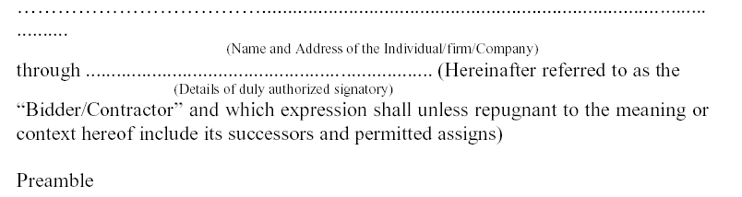

WHEREAS the Principal /Owner has floated the Tender (NIT No. 20/Civil/D2/2020-21/03) (hereafter referred to as “Tender / Bid”) and intends to award, under laid down organization procedure, contract for “Making emergency exit on first floor with spiral fire escape and making concrete path for block B in pre-engineered building near Flight lab”.

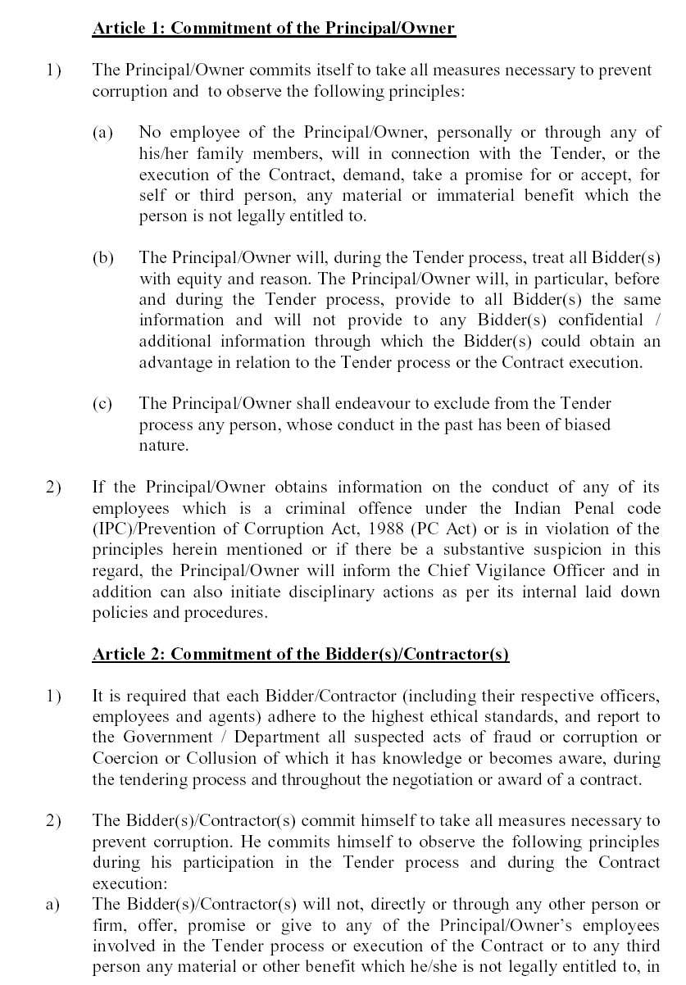
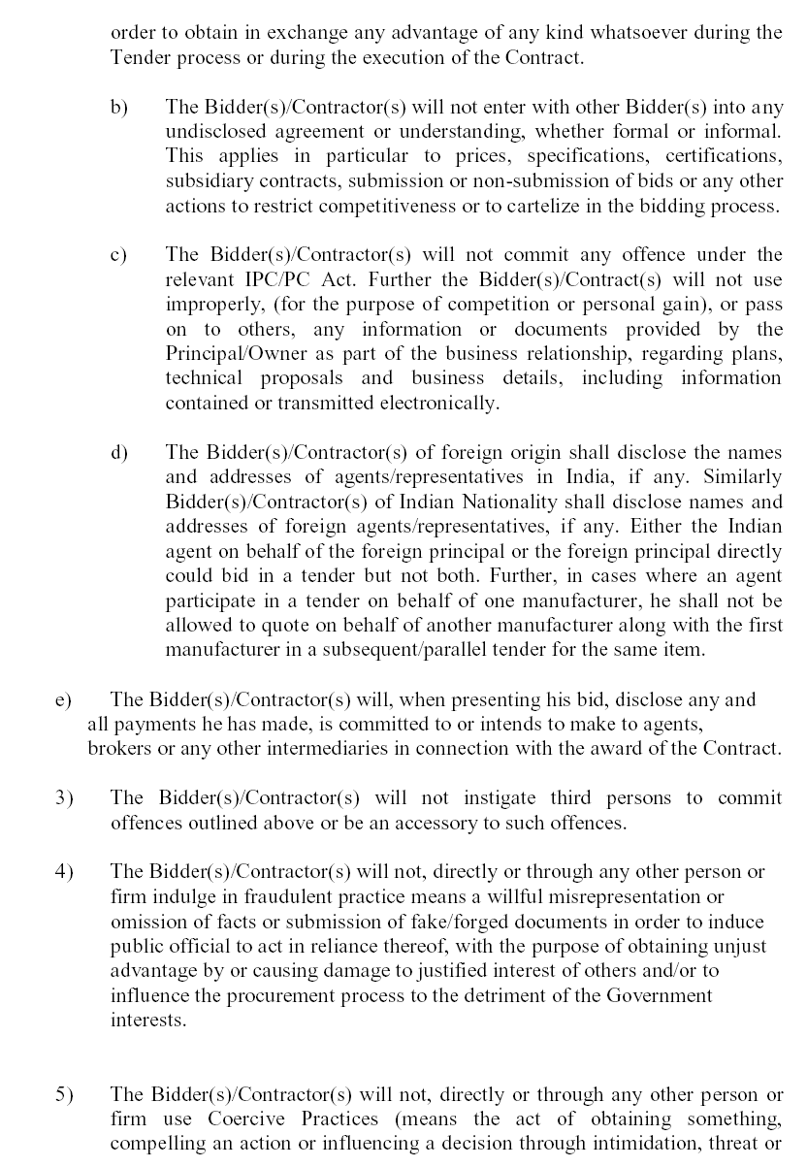

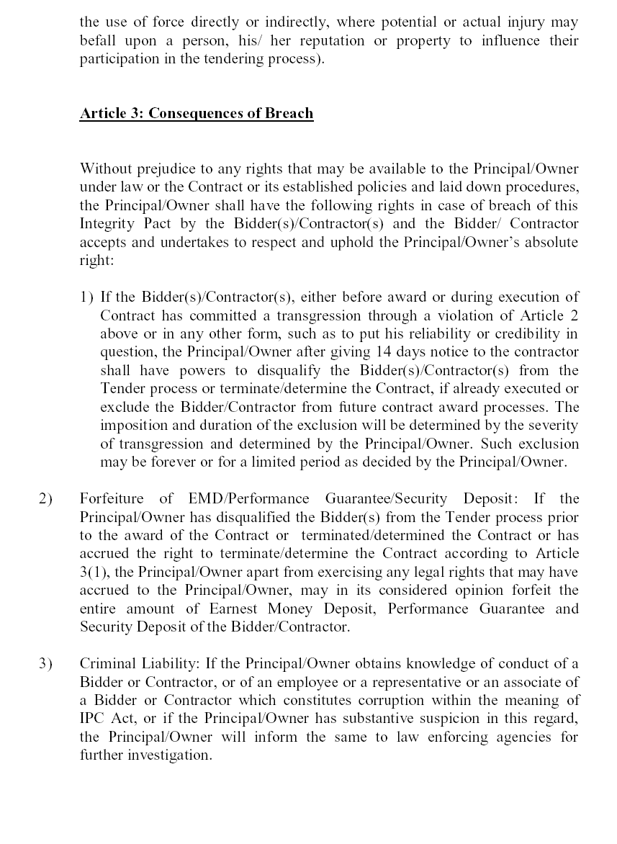

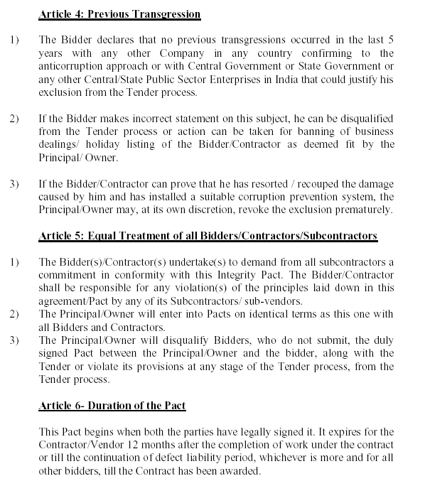

If any claim is made / lodged during the time, the same shall be binding and continue to be valid despite the lapse of this Pacts as specified above, unless it is discharged / determined by the Competent Authority, IIT Kanpur.

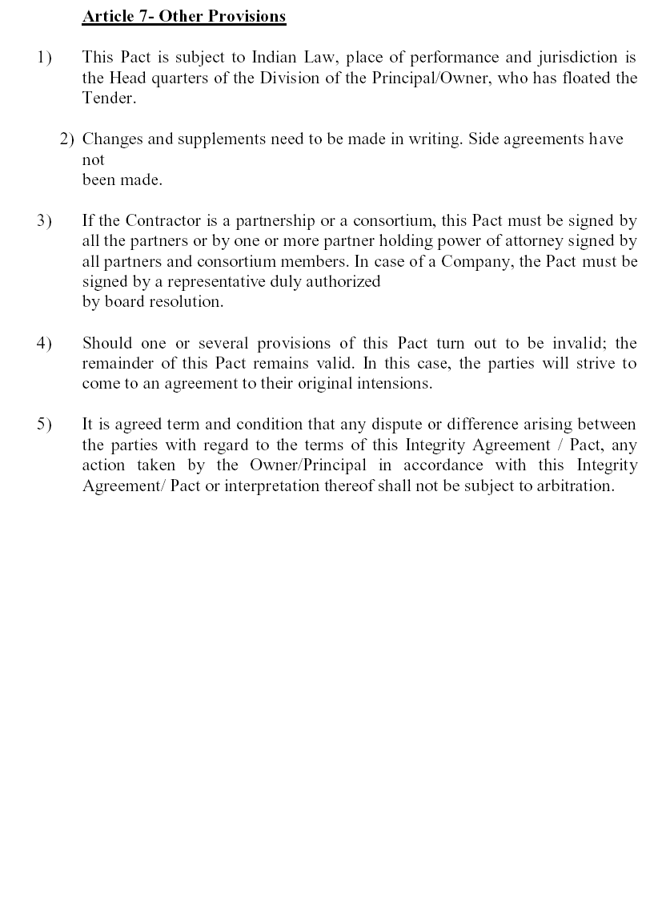

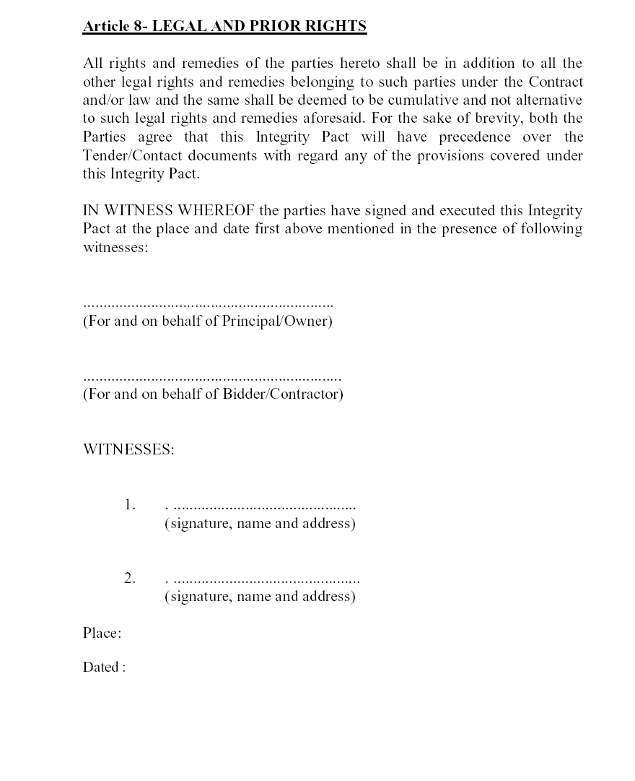

BANK GUARANTEE BOND DRAFT
In consideration of the Board of Governors of IIT Kanpur (hereinafter called “the Government”) having agreed under the terms and conditions of agreement No. _______________________ dated ______________ made between _____________ and __________________ (hereinafter called “the contractor(s)”) ____________ for the work ____________________________________________________ (hereinafter called “the said agreement”) having agreed to production of a irrevocable Bank Guarantee for Rs. ___________ (Rupees _____________________________________ ______________________________________________ only) as a security/guarantee from the contractor(s) for compliance of his obligations in accordance with the terms and conditions in the said agreement, we
(hereinafter referred to as “the Bank”) hereby undertake to pay to the
(Indicate the name of the Bank)
Government an amount not exceeding Rs.__________ (Rs. ________________________________ only) on demand by the Government.

2. | We |  | do hereby undertake to pay the amounts due and payable
 |  | (Indicate the name of the Bank)
under this Guarantee without any demure, merely on a demand from the Government stating that the amount claimed is required to meet the recoveries due or likely to be due from the said contractor(s). Any such demand made on the bank shall be conclusive as regards the amount due and payable by the bank under this guarantee. However, our liability under this guarantee shall be restricted to an amount not exceeding Rs. _________ (Rupees __________________________________ only).

3. We, the said bank further undertake to pay to the government any money so demanded notwithstanding any dispute or disputes raised by the contractor(s) in any suit or proceeding pending before any court or tribunal relating thereto, our liability under this present being absolute and unequivocal.
The payment so made by us under this bond shall be a valid discharge of our liability for payment thereunder and the contractor(s) shall have no claim against us for making such payment.

4. | We |  | further agree that the guarantee herein contained shall
 |  | (Indicate the name of the Bank)
remain in full force and effect during the period that would be taken for performance of the said agreement and that it shall continue to be enforceable till all the dues of the Government under or by virtue of the said agreement have been fully paid and its claims satisfied or discharged or till Engineer-in-charge on behalf of the government certified that the terms and conditions of the said agreement have been fully and properly carried out by the said contractor(s) and accordingly discharges this guarantee.

5. | We |  | further agree with the Government that the Government
 |  | (Indicate the name of the Bank)
shall have the fullest liberty without our consent and without effecting in any manner our obligations hereunder to vary any of the terms and conditions of the said agreement or to extend time of performance by the said contractor(s) from time to time or to postpone for any time or from time to time any of the powers exercisable by the government against the said contractor(s) and to forebear or enforce any of the terms and conditions relating to the said agreement and we shall not be relieved from our liability by reason of any such variation, or extension being granted to the said contractor(s) or for any forbearance, act of omission on the part of the government or any indulgence by the Government to the said contractor(s) or by any such matter or thing whatsoever which under the law relating to sureties would, but for this provision, have effect of so relieving us.

- This guarantee will not be discharged due to the change in the constitution of the Bank or the contractor(s).

7. | We |  | lastly undertake not to revoke this guarantee except with
 |  | (Indicate the name of the Bank)
the previous consent of the Government in writing.

8. This guarantee shall be valid up to _____________, unless extended on demand by Government. Notwithstanding anything mentioned above, our liability against this guarantee is restricted to Rs. _________ (Rs. _______________________________only) and unless a claim in writing is lodged with us within six months of the date of expiry or the extended date of expiry of this guarantee all our liabilities under this guarantee shall stand discharged.

Dated the ___________________________ day of ______________________________________________
for
(Indicate the name of the Bank)

DRAFT
